(Approx. 380 words)

NAB (National Association of Broadcasters) Conference
A review by George Harding, Treasurer, Tucson Computer Society
www.aztcs.org
georgehardingbds (at) earthlink.net

The National Association of Broadcasters conference is primarily a showcase for equipment and software the broadcasters use to bring to you the Nightly News and other important presentations.
(Note: This year, it was held from April 7 to April 12 at the Las Vegas Convention Center.)

The equipment includes TV cameras lighting sources, hardware used in remote broadcasts and containers for transporting all the stuff that needs to get from one place to another.

The software takes many forms, but a common one is to make a TV stage appear to be multi-dimensional, with panels that display moving images and dramatic text. The video and pictures relate to the story unfolding by the screen readers.

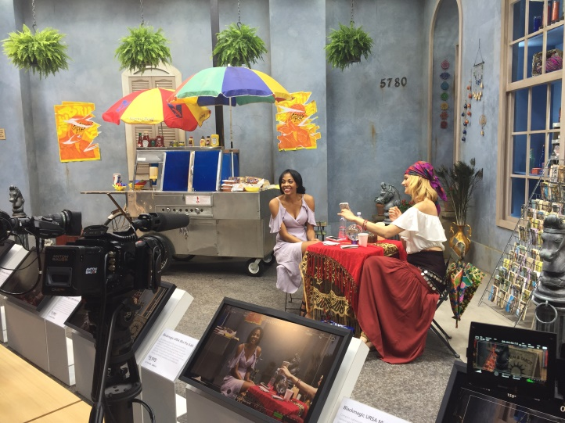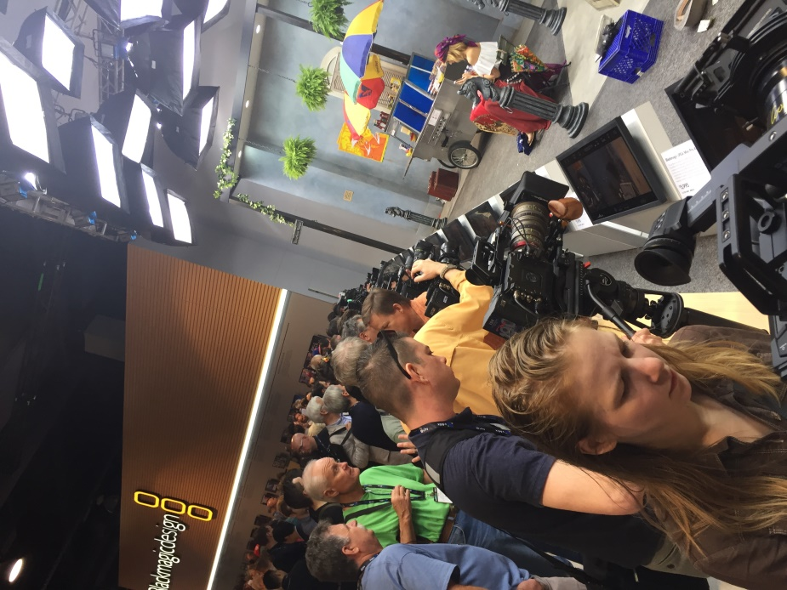

In order to allow purchasers to see how various TV cameras display images, some vendors had a range of cameras set up in front of a stage with a few good-looking people doing meaningless tasks or just talking, with colorful items on display. This gives the opportunity to try out one of more of the TV cameras to see how easily and dramatically each shows color, action and detail.

Container vendors have multiple boxes and crates for hardware transport, with compartments specially constructed to fit one’s cameras, lights and other equipment.
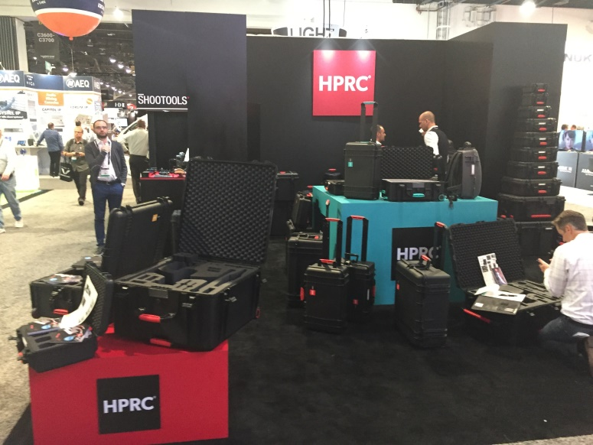
One of the most interesting panels offered at this show is Behind the Scenes, which presents those who were involved in making a movie or TV series. You hear how the difficulties were overcome, costume designs, makeup and other aspects of the project were accomplished.

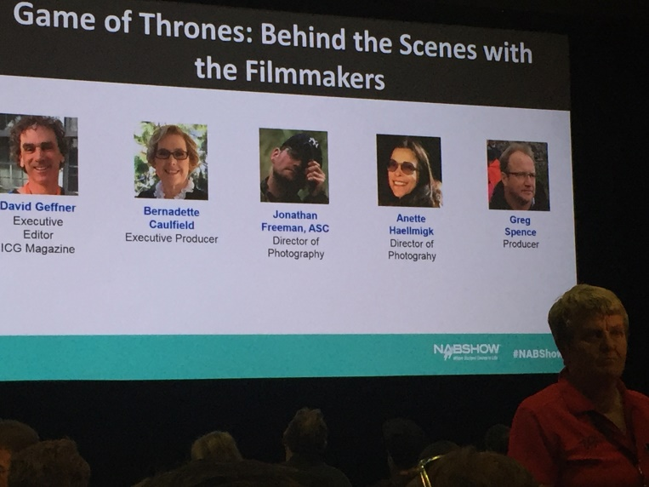
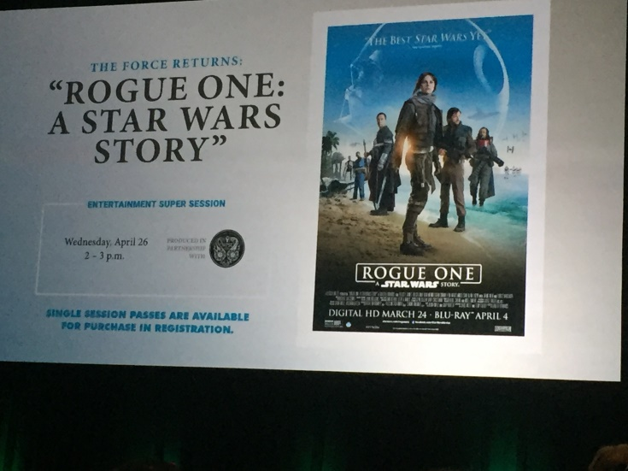

Another fascinating feature was a panel contacting the International Space Station. Two of the astronauts were shown on screen and conversed with the moderator. Because of the distance between Earth and the Space Station, voice transmission involved a two-minute wait between speaking and hearing the spoken word.

The astronauts performed several experiments, including playing ping pong with a water bubble! The bubble went in unexpected directions when touched by a paddle, so the experiment was not very successful. Weightlessness was another demonstration.

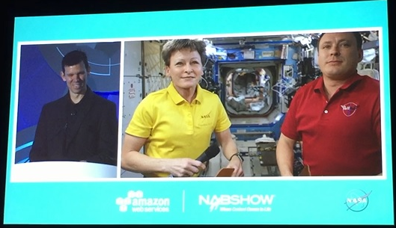

NAB has lots of interesting things to see and learn about, even for those not in the broadcasting industry!

National Association of Broadcasters
www.nab.org
Admission price varies

